Contents

Outline: 1

Organised Outline 2

Interesting Quotes and ideas from automation papers. 2

Things to add 3

Artificial Curiosity: A Search for Novel Chemistry and Chemical Understanding. 5

Main 5

Workflow Overview 8

Defining Chemistry 8

Dataset Generation 10

Feature Selection 10

Data Generation 17

Data Exploration 19

X-ray Crystallographic data 19

Spared information to be compiled into a coherent document. 19

References 19

Supplementary Information 22

# Outline:

* Hypothesis: it is possible to learn new chemistry from a robotic ML platform.
* Definition of chemistry and how it defines the search space.
* Removal of bias from sampling all combination reactions.
* Bias of decision maker for single, discrete, diamagnetic supramolecular structures.
* Add reagents used for generation of sample space.
* The choice of reagents were based on: bite angle, rigidity, aromaticity, chirality, sterics, metal valency, and metal size.
* Strength of using ML systems: analysis of huge amounts of data and come to unintuitive decisions.
* Supramolecular chemistry is chosen due to its combinatorics, complexity, easy reaction conidiations to automate, reactions being in equilibrium make single discrete species making it easier to be analysed by NMR.
* The advantage of automation comes with its organisation, (and a bit of saving human effort). Humans get tired and bored and will therefore mess up making up tens of different reactions. Robotic platforms do not have this issue and follow steps to the dot.
* The choice of features for model.
* What is SHAPS and how can it be used for inference (if smiles representations are used, SHAPS will highlight what part of the molecule has the greatest say in prediction).
* The physical setup of the platform.
* How the workflow operates.
* Discovery of Novel structures via a more reasoning approach. If this proof of concept works, the paper would not only have provided insights into the chemistry, but to the fact that ML can infact learn chemical rules. The ML can then be trained on a subset of the combination space, and then predict chemical structures for the remainder. This allows for the discovery of novel compounds without neccasrly having to carry out reactions.
* Robotic platforms allow for the standardisation of reactions, helping bridge the information gap present in todays research1.

# Organised Outline

1) Introduction:

* Hypothesis: it is possible to learn new chemistry from a robotic ML platform.
* Removal of bias from sampling all combination reactions.
* Strength of using ML systems: analysis of huge amounts of data and come to unintuitive decisions.
* Supramolecular chemistry is chosen due to its combinatorics, complexity, easy reaction conidiations to automate, reactions being in equilibrium make single discrete species making it easier to be analysed by NMR.
* The advantage of automation comes with its organisation, (and a bit of saving human effort). Humans get tired and bored and will therefore mess up making up tens of different reactions. Robotic platforms do not have this issue and follow steps to the dot.
* Discovery of Novel structures via a more reasoning approach. If this proof of concept works, the paper would not only have provided insights into the chemistry, but to the fact that ML can infact learn chemical rules. The ML can then be trained on a subset of the combination space, and then predict chemical structures for the remainder. This allows for the discovery of novel compounds without neccasrly having to carry out reactions.

2) Results and discussion:

* Definition of chemistry and how it defines the search space.
* Bias of decision maker for single, discrete, diamagnetic supramolecular structures.
* Add reagents used for generation of sample space.
* The choice of reagents were based on: bite angle, rigidity, aromaticity, chirality, sterics, metal valency, and metal size.
* The choice of features for model.
* What is SHAPS and how can it be used for inference (if smiles representations are used, SHAPS will highlight what part of the molecule has the greatest say in prediction).
* The physical setup of the platform.
* How the workflow operates.
* Robotic platforms allow for the standardisation of reactions, helping bridge the information gap present in todays research1.

3) Conclusions:

# Interesting Quotes and ideas from automation papers.

# Things to add

Talk about the limitation and how the project could be expanded. Change the reaction space to new combinations, add X-ray crystallography workflow, vary temperatures (reaction conditions).

‘The adoption of the user-friendly reaction data format (SURF[41](https://www.nature.com/articles/s42004-023-01047-5#ref-CR41)), facilitated the collection of reaction data from literature sources and enabled standardized reporting of results from HTE and virtual reaction screening. Sharing reaction data in a standardized format plays a pivotal role in the effective utilization of machine learning models for predicting chemical reactivity[44](https://www.nature.com/articles/s42004-023-01047-5#ref-CR44),[45](https://www.nature.com/articles/s42004-023-01047-5#ref-CR45). By using SURF, the initi'al reaction data from three distinct sources (45 from literature, 207 from experiments, and 368 decoy reactions) became readily available for machine learning, obviating the need for manual data curation. Since both the experimental and, particularly, the literature data are predominantly comprised of positive results, incorporating decoy data from unsuccessful transformations played a crucial role in constructing a dependable prediction model.’2

Have a section describing the chemist time vs reaction time (i.e. robotic platform v human chemist time).

Talk about possible future work (this is required by UofG)

Make how parameters as acquired clearer.

Make how programme takes in chemist measured masses to calculate solvent volumes.

The majority of the chemists efforts and time went into setting up the workflow, and setting up runs.

Introduction of metal-organic supramolecular architectures.

Better link between paragraphs.

The imine constitutes as faces or edges of polyhedral structures, while metals act as glue and therefore are found at the vertices of these structures3. One can imaging such simplicity creates a diverse landscape of possible geometric structures. Fortunately, either the kinetic or thermodynamic product is favoured. These geometric structures are governed by chemical rules.

Reactivity and coordination geometry of the metal is a key component in determining structure topology4. Coordination preferences of metals results in vertices with well-defined linker directionality4.

‘In this study, we design and investigate a highly automated workflow that synergizes a high-throughput experimentation platform with a state-of-the-art active learning algorithm to significantly enhance the solubility of redox-active molecules in organic solvents.’5

‘With our automated HTE workflow, the total experimental time to finish the solubility measurement for 42 samples is ca. 27 h (~39 min/sample, less time per sample with running more samples). As shown in Fig. 2g, this is more than 13 times faster than processing samples one by one manually using the ‘excess solute’ approach, which requires approximately 525 min per sample (Supplementary Table S1). While the screening speed of our HTE workflow based on the ‘excess solute’ method is comparable to that of the automated platform proposed by Shiri et al. (20–80 min/sample)27, there are two important distinctions. First, we measured thermodynamic solubility, whereas Shiri and co-workers used the ‘excess solvent’ method for kinetic solubility measurements. Second, our workflow processes 42 or more samples at once, while Shiri et al.’s platform operates on one sample at a time.’5

Structures of coordination driven supramolecular chemistry can be simplified based on the number of binding sites on the metal, the orientation of these binding sites, the number of lewis-acid sites on the ligand, and the orientation between these sites6. These are some of the main features used to describe a supramolecular metal-organic structure, and are the same features which effect topology.

1. Importance of being able to filter reactions. Since space is huge method for exploring and cutting down space is required.
2. Is not a new idea (ML for seive) or HTS with ML for data processing and analysis, but what is missing is a complete automated end to process starting from the selection of chemistry to determining reaction outcome based on sample spectra.
3. Combination of ML and HTS is powerful for three main reason (reasons for the power of selecting HTS with ML):
   1. Ab initio calculations not so possible / Complexity of data ML can understand and process:
      1. Additionally, the use of robotic systems to physically explore the space allows for training on experimental data and outcompetes any ab initio explorations due to the latter’s associated computational costs7.
   2. Robots are better than humans:
      1. Thirdly, robots focus on the mundane tasks, allowing the chemist to focus on the intellectual challenges. Likewise, by improving reproductivity and accuracy of results, robotic platform reduces human error8.
   3. Interpretation of ML for improving ML decision reliability.
4. What is imine complex chemistry.
   1. This paper focuses on imine chemistry for several reasons: give list.
   2. The paradigm of self-assembly is perfect for use with ML for this project.
   3. The complexity of chemistry makes it hard for humans to act as sieves.
      1. Beyond the basic question of whether a given material is likely to absorb visible light, these factors are generally hard to predict. Also, the variables interact in complex ways:[11](https://pubs.rsc.org/en/content/articlelanding/2021/sc/d1sc02150h#cit11) for example, porosity might be desirable to increase the catalyst surface area, but it might also reduce charge carrier mobility. To deconvolute such multivariate relationships, we need algorithms to model multi-dimensional datasets. We also need a sufficient volume of data to create meaningful models. At present, most studies in the literature are focused on a handful of catalysts, making it difficult to probe general structure–activity relationships9.
   4. Experimental chemistry is very multifaceted so it is very hard to create a universal automated synthesis platform. Simple chemistry to perform via robots is therefore imperative. The current platform we are using is chemspeed which is pridominatly a liquid transfer robot, so we have to use this to our advantage.
   5. High symmetry makes it more simple to anaysle MS and NMR for reaction outcome.
      1. Give example of chemistry that is not good for THE (i.e. requires tags which might change the chemical properties of the system).
   6. Combinatorial space.
5. Overall the paper focuses selecting appropriate features for the sieve, synthesis of reactions in the chemical space, automated analysis of reactions for label generation via a heuristic thing, training and test of ML and lastly improving prediction reliability by making model decisions human interpretable.
6. Creating sieve requires a ML. A functional ML has to be trained and tested. This requires the generation of a dataset with features and labels.
7. These must be selected first.
8. The features we selected are.
   1. Talk about relevant chemistry
9. Due to the limited number of datapoints, for the masteres project we selected only 7
   1. List what 7
10. The label we chose is a binary classification where 0 and 1.

To populate the table 4 programmes were required.

1. Talk about programme for defining chemical space.
2. Talk about programme for finding out features
3. Talk about programme for synthesising and analysing chemical space.
4. Talk about decision maker and populating the table.

the ML can now be trained and tested. With trained model, SHAPs analysis was used to make it human interpretable.

1. Explain what SHAPs is.
2. Give conclusions which are made with SHAPs analysis.
3. Data interpretation section.

Future work

1. Platform for X-ray crystal growth
2. Testing out combination to study self sorting
3. Testing out sieve on new, slightly different dataset
4. Still lots of manual processes
   1. Using KUKA for sample transport.
   2. Better filtration method
5. Make it closed loop so more easy to expand on platform (currently first running all reaction and then using decision maker).

Conclusions

# Artificial Curiosity: A Search for Novel Chemistry and Chemical Understanding.

Serendipitous discoveries, such as Wittig olefination, play a major role in Chemistry, revolutionising different industries. Unfortunately, this makes finding new materials and compounds with useful properties both rare and unpredictable. If compound formation can be rationalised or alternatively, if the chemical space can be sieved through quickly and reliably, new materials can be found more consistently. Here we present a workflow that generates a chemical dataset on imine-based metal organic complexes to understand their formation rational and to build a reaction sieving tool. This workflow synthesises and analysis different combinations of diamine, monoaldehyde, and metals on a high through put platform and a heuristic decision maker determines if the combination is successful or not. The merging of HTE and automated spectra analysis generated a dataset of 376 different reactions. Afterwards, machine learning algorithms are used both as a sieve and for its ability to interpret complex relations in the space. The sieve is then used to further provide chemical insights and to improve its sieving reliability by making its decision-making processing human interpretable. Overall, the scope of the paper is to build a workflow that generates a dataset for developing a chemical understanding and for sieve building and testing as both help locate areas in the chemical space with valuable compounds.

## Main

The chemical space is huge. It is thought that the total space of organic small molecules (<500 daltons) is in the order of 1060 compounds10. Its massive!

Serendipity still plays a central role in sampling such a large space that then lead to the discovery of novel compounds and chemistry. Such random molecular and material discoveries have aided in tacking challenges in healthcare, materials, energy storage, and sustainability. Just to name a few Nylon, ferrocene, fullerene, electrically conducting polymers, and Wittig olefination were all discovery by chance11. Cases where new materials were developed from theory12 are the exception rather than the norm, one must just look at the field of catalysis10.

Since development of materials from theory is rare, a more systematic approach to sampling the chemical space is required. One method is to filter the space based on reactions that work, which is possible with using a machine learning model (ML) as a sieve, trained on data produced on a high throughput platform5,9. Such tools also help develop a better understanding of the chemistry such that compound development from theory is made less rare. However, the current literature is missing is a more wholistic automated end to end process, starting from the selection of chemistry to determining reaction outcome based on sample spectra. This end to end HTE workflow combined with automated analysis, comes with it three key advantages.

Firstly, screening manually or via Ab initio calculations is not feasible. The number of chemical parameters to consider simultaneously and their complex interplay makes it hard for a human to predict if reagents form a complex or not. Additionally, the use of robotic systems to physically capture the chemical space allows ML models to be trained on experimental data and outcompetes any ab initio explorations due to the latter’s associated computational costs7. Therefore, ML screening and analysis is a powerful option for chemical space exploration and understanding as its able to capture complex relations based on real world data.

Secondly, data is gathered via a robotic platform. This ensures chemist experiment time is minimised, allowing them to focus on other work, especially with hundreds of reactions to carry out. Also, robotic platforms improve reproducibility, accuracy and standardisation of results, reducing human error and making datapoints analytically comparable and meaningful8. Therefore, acquiring data with a robot improves ML, dataset and experiment reliability.

Thirdly, if explainable ML are implemented, this improves decision making reliability while developing the chemists chemical understanding13. Explainable AI are ML algorithms that have the ability to make their decision-making process more understandable to the user. One method of gaining insights into the model’s logic is via SHAP analysis. Simply put, SHAP analysis allows the chemist to understand what parameters were the most relevant for a ML model to predict reactivity. Due to SHAP’s game theory approach, SHAP analysis lies in local explanations but may be used for global explanations. Local explanations would look at the chemistry of a single reaction, while global explanations would look at the general chemical trend - both provide powerful insights of the explored chemistry. It’s clear that ‘exlainabilty’ cements the chemists understanding of the explored space and their trust with the model’s extrapolative abilities. It therefore makes sieving more robust as it provides a rational of how and why the filtration decision was made (i.e. allows an expert to validate the model’s decision-making reasoning).

While the workflow does come with several advantages for space exploration, it does not negate the fact that the whole chemical space is still massive. Therefore, to test such a workflow, the chemical space is cut down to imine-based metal organic complex chemistry. A smaller space allows for an exhaustive analysis of all reaction and products, to build chemical understanding and a reaction sieve. The created sieve and newly acquired chemical knowledge can then be transferred to a larger space to locate interesting synthetic areas.

As the name suggests, imine-based metal organic complexes, are formed on the basis of reacting amines and aldehydes to form imines which may then coordinate to metals. The formation of imines and metal coordination are dynamic equilibrium processes driven by molecular recognition14. When diamines are involved, the formed imines behave as linkers between metal centres, creating complex topology. The topology of the formed supramolecular structures is programmed in the molecular codes of the building blocks, directing sorting and self-assembly15.

Some molecular codes found in imine-based metal organic complexes, include geometric complementation, sterics, and coordination sphere codes15. These are by no means an exhaustive list of codes.

Geometric complementation is at the heart of this self-assembly process. The interacting groups that form a directional bond (which drives the assembly process) require a geometrical fit first15. This fit comes in the form of size, shape, and rigidity of the linkers as well as the metal vertices. Once this geometry is satisfied, more nuanced codes come into play. Namely, steric and coordination sphere interactions.

Sterics affect the spatial arrangement of linkers, which in turn affect the topology of the complex. The steric code introduces strain to the geometric complementation, which may result in a change of topologies with the introduction of a different bulky group on the same linker scaffold. It is important to note, the introduction of such a group could introduce new intra or intramolecular bonding which affects the original geometric complementation code. The same steric codes also affect coordination sphere codes.

Coordination sphere codes tend to dictate supramolecular topology and formation, as metals behave as vertices3,4. Coordination sphere codes capture the geometry of a vertex, its number of edges and the angles between these edges. The number of chelating imines on a vertex is effect by coordination number, while the vertex angles are governed by both metal geometry and steric codes. Metal geometries are distorted by steric codes as these may introduce strain in the coordination centre. This hierarchy and interrelations of molecular codes highlight the complexity and what chemistry might affect reaction outcome.

With this brief introduction of imine-complex chemistry, it is possible to show its compatibility with the paper’s workflow. The synergy between the chemistry and workflow is shown by the chemistry’s paradigm, the intricacies of molecular codes, the simplicity of supramolecular reactions, the chemistries high combinatorics, and supramolecular topology.

To be able to predict the out come of a reaction without having to physically carry one out (i.e. the scope of the sieve), all the information of what makes a reaction successful must be encoded in the starting materials. As mentioned previously, the architecture of the complex is encoded in the metal-ligand building blocks4. Therefore, the machine learning tool has the ability to infer and predict the success of a reaction based on reagent information alone. This supramolecular paradigm makes the chemistry compatible with the project.

Moreover, the advantage of ML comes in its ability to explore complex and unintuitive data with speed and minimal computation16. As shown by the interdependence of steric, coordination and geometric molecular codes, predicting reactivity based on reagents is a challenging multivariable function. This unintuitive convolved chemistry, is a perfect test case for extracting chemical information with ML tools.

Experimental chemistry is a multifaceted problem and while making universal synthesis platforms have been attempted, they still lack real universality17,18. Additionally, the robot used in this study is a ChemSpeed liquid handling robot. Therefore, if reactions are to be taken reliably, the chemical space has to be limited to reactions which can be handled by the ChemSpeed. Since, imine formation and metal coordination are spontaneous at lower temperatures, the ChemSpeed does not need to be modified to resist and handle high temperature reactions19. Also, imine formation and metal coordination are orthogonal14, which allows for one pot reactions, reducing the number of base steps and reaction vials in the robotic workflow. Additionally, the solubility of many metals, amines, and aldehydes in acetonitrile and dichloromethane, allows for the ChemSpeed to handle reagents in the form of stock solutions with a standard solvent. Again, having a standard solvent reduces the number of base steps, limits the number of solvent peaks in an NMR spectrum for reliable analysis, and more importantly, plays the robots forte: liquid handling. Thus, the dynamic self-assembly of imine complex chemistry ensures the robotic platform is not a bottle neck of the project but rather a strength.

When it comes to automated spectra analysis, imine complex chemistry has advantages resulting from its reversibility and topological structure. The dynamic nature of imine and metal ligand bonds allows for the selection of the thermodynamic product20. The formation of a single species along with the high symmetry of its topology, simplifies the automated identification of a successful reaction due to a cleaner NMR spectra and splitting pattern. This is supported by previous research, where protons in a supramolecular complex exhibit a single chemical and magnetic environment, while ESI-MID elucidated the stoichiometries of building blocks of the architectures21. Unfortunately, both NMR and MS are not enough to fully characterise the architecture of a supramolecular structure. The formation of a high symmetry discrete species which can be identified in automation is another reason for the use of imine-based complexes in the work flow.

Lastly, imine coordination chemistry was chosen due to its combinatorics. Unlike in catalysis where HTE are limited by catalyst and ligand libraries10, the diversity of commercially available aldehydes and amines does not make reagent selection a limiting factor in this study19. Furthermore, the diversity of mono-aldehyde and diamines provide the ML the opportunity to learn the complex underlaying molecular codes. The combinatorial accessibility also lends to understanding self-sorting in future work based on exploring supramolecular structures with multiple metals, amine and aldehydes in a reaction. The combinatorics allows for a greater scope of the project, while ensuring a varied dataset can be generated.

Imine complex theory is convoluted and its chemistry is best suited for the robot used in for HTE. This makes it a perfect chemical space to test the work flows capabilities.

## Workflow Overview

To recapitulate, the project focuses on being able to understand and filter a chemical space, to then locate areas of potentially useful chemistry. The chemical space is reduced to imine-based metal organic complexes due to its compatibility with automation as well as to be able to exhaustively explore this smaller space for analysis. To do so, the work flow is divided into sections.

Firstly, the subset space is made explicit by selecting reagent libraries and populating the space with building block combinations. The combination space is then translated to the chemical space. Secondly, to train, sieve and explore the space with ML models, a table of features and labels need to be selected and populated. This requires chemically relevant features to be selected, and the creation of a robotic workflow that automates synthesis and reaction labelling. Once the features and labels have been generated, then analytical ML studies can be implemented. The process from defining chemistry to data analysis is shown in Figure 1 – an overview of the study.

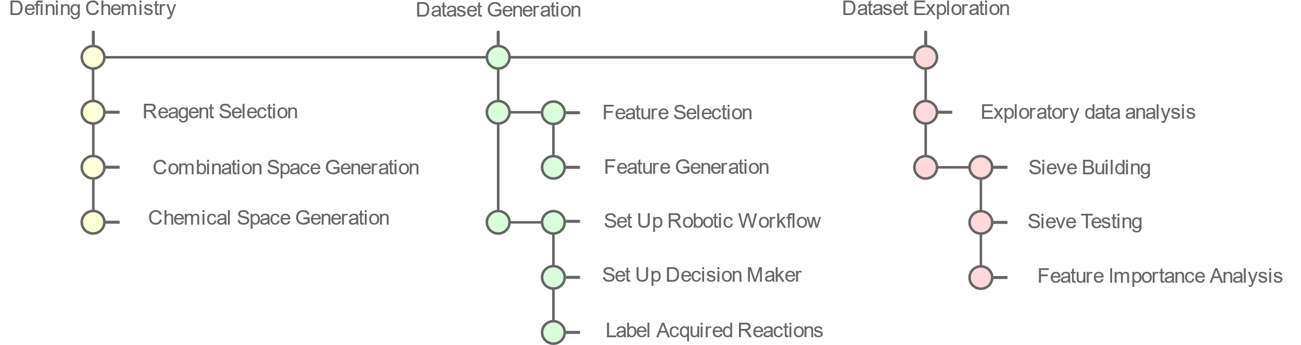

Figure : An overview of the study preformed in the paper, subdivided into three sections: defining chemistry, dataset generation and dataset exploration. The first section is responsible for defining the chemical space to explore and the generation of reactions to be carried as HTE. The second section is responsible for feature and label generation. The third section analyses the data of the chemical space, builds and test the sieve along with SHAPs analysis.

## Defining Chemistry

The paper focuses on developing an end to end automated process. For this reason, all chemistry has to be unambiguously defined and represented digitally, as robots do not work well with ambiguity. Starting off with defining the chemical space. The chemical space are all the possible products of combinations of reagents of a reaction (i.e. all the possible combinations between amines, aldehydes and metals). To generate this space, the reagent library is first defined, where all the reagents of interest are listed under their functional group. Figure 2 shows the reagent libraries used in the paper along with an example reaction product.

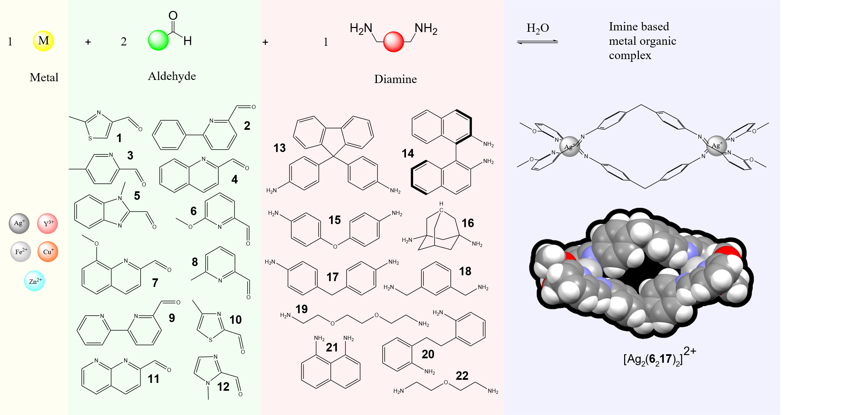

Figure : The reaction (shown above) explored in the study. Reagent libraries for metals, monoaldehydes and diamines are shown in yellow, green, and red areas respectively. An example supramolecular compound found in the study, and its 3D structure obtained from x-ray crystallography are also shown.

10 different diamines, 12 different monoaldehydes and 5 different transition metals were selected based on commercial availability, a nitrogen beta to the carbonyl group and the diamagnetism of the metals. A beta nitrogen forms a chelate after imine formation and a diamagnetic metal prevents uninterpretable paramagnetic NMR spectra. A full list of reagents and their names are found in S 1. If the sieve is to be used in a larger space (as for future work), and to get a broader understanding of the chemistry, reagents with varied chemistries must be selected. The variety of bite angles, rigidity, aromaticity, chirality, sterics, electronegativity, metal valency, and metal size of reagents in Figure 2 ensures different molecular codes are captivated in the chemical space. This variety develops a deeper understanding of the chemistry, and makes the ML sieve more generalisable and therefore sturdy against chemical reactions it has not seen before. For example, when exploring new spaces.

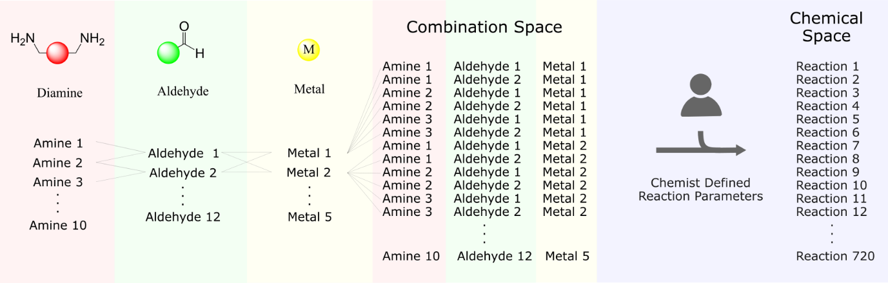

Figure : The generation of the combination space which is then translated to the chemical space, once combinations have translated to reactions via user defined reaction parameters.

Once the reagent library has been selected all possible combinations between reagents are taken, forming the combination space (Figure 3). This generates 720 (coordination numbers of 4 and 6 are included for silver) combinations.

This combination space is chemically meaningless for the robotic workflow. Therefore, for the workflow to generate the chemical space, the chemist has to input reaction parameters to translate combinations to reactions (Figure 3). Parameters include: reagent concentrations, transfer volumes, reaction temperatures, reaction duration, and buffer volumes. This paper takes combinations of reagents in a 2:3:6 metal:diamine:mono-aldhdye ratio, heats them at 60oC for 40h to create reactions. While there are 720 reactions in the chemical space, due to time constrains, this master (MSci) project was only able to synthesis and analyse 376 reactions.

The four steps of selecting reagent libraries, generating a combination space, taking in user defined parameters to generate the chemical space is handled via a programme written by the group. As mentioned before, having a computer representation allows for an automated end to end workflow. In fact, the chemical space generated by the programme is then used for Dataset Generation.

## Dataset Generation

With the chemical space defined and with the intentions to analyse the space with ML, features and labels must be selected and generated.

### Feature Selection

Feature selection was based on ideas from molecular coding and the supramolecular paradigm which have been outlined in the introduction. More specifically, since reactions contain a metal, an aldehyde, and an amine, reaction features can be split based on the three reagents. Therefore, a supramolecular structure resulting from a reaction in the chemical space is represented by its building blocks (Figure 4). The building blocks, in turn, can be further represented and their chemistries described.

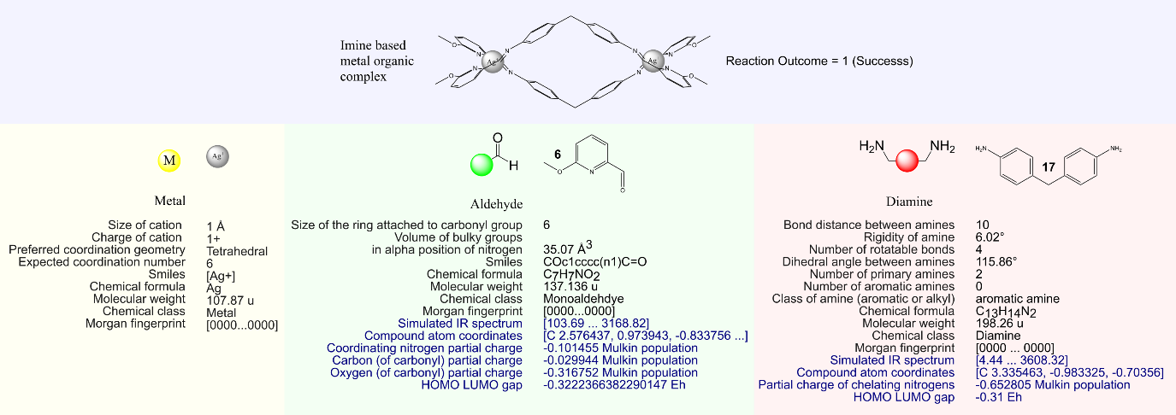

Figure : Decomposition of a reaction into reagents with their respective relevant features and representations used for data analysis. Example features and representations are given for reaction 109 (Silver + reagent 6 + reagent 17). Reaction 109 was successful and the formed supramolecular structure is shown. Features in blue are calculated via quantum mechanical means in orca. Features in black are extracted via cheminformatics toolkits.

Features that were select to embody the geometric complementation, sterics, and coordination sphere codes are: size of metal cation, charge of metal cation, preferred metal coordination geometry, expected coordination number, volume of bulky substituent in the coordination sphere, the partial charge of the coordinating nitrogen, bond distances between amines, rigidity of amines, number of rotatable bonds between amines, and the angle between amines.

Features that do not fit the outlined molecular codes are: the size of the ring attached to the carbonyl group, the partial charges of the carbonyl oxygen and carbon, the simulated IR spectra, HOMO-LUMO gaps, and if the amines are bonded to aromatic or aliphatic groups. These were selected to provide insight to imine reactivity.

Other information shown in Figure 4 are either ML interpretable molecular representations or additional information of the reagent.

As mentioned previously, for this Master (MSci) project the final dataset only contains 376 datapoints. Due to SHAP’s coalitions approach, the small dataset limits the number of features that may be used in a SHAPLY analysis. Therefore, only 7 of the relevant features in Figure 4 were selected for later use in dataset exploration.

For metals the cation size was chosen as this indirectly contains information of the charge (greater charges result in smaller radii), and possible geometries (smaller radii limit the number of ligands and covalency). Bennett et al. have highlighted the importance of cation radii in coordination to polypyridine ligands both in terms of chelation and preorganisation22. Cation sizes are expected to, therefore, affect topology and reactivity.

For aldehydes, the thesis focuses on the partial charge on the carbon of the aldehyde, the volume of bulky groups in coordination sphere, and the ring size attached to the carbonyl. The author expects the partial charge on the carbonyl carbon to dictate reactivity with amines, where lower electron populations results in a better electrophilic centre for an attack from the amine. Furthermore, it is thought that substituent volumes constrain imine metal coordination and supramolecular vertex geometry. For instance, a bulkier group may affect preorganisation of the imine for a specific metal, introduce steric strain between two coordinating imines and if exaggerated may prevent another imine from coordinating. This demonstrates volume of bulky group is a good representative of steric and coordination sphere codes. Lastly the authors think ring size provides further information on both supramolecular topology and imine reactivity. The size of the ring controls the number of double bonds conjugated to the imine and the carbonyl group, affecting their reactivities. A larger ring size also increases the steric presence of the imine and therefore is part of the steric code.

Lastly for amines, the selected features are: the nature of the amine (if its bonded to an aromatic group or not), the enforced angles between the two amines, and the number of rotatable bonds between amines. For similar reasons as the aldehydes, resonance of aromatics with amine groups affect the reactivity of both imines and amines. The dihedral angle between amines affects linker coordination direction, while the number of rotatable bonds provide information on the slack the amine can take. The authors expect the amine to behave as linkers, hence more features that encapsulate geometric complementation codes were chosen. These code in turn affect topology and more importantly dictate if complexes are formed or not.

### Feature Generation

Since the focus is on automating the entire workflow process (Figure 1), including feature selection and generation, a program was written to extract features outlined in the previous section. The general structure of the program is shown in Figure 5.

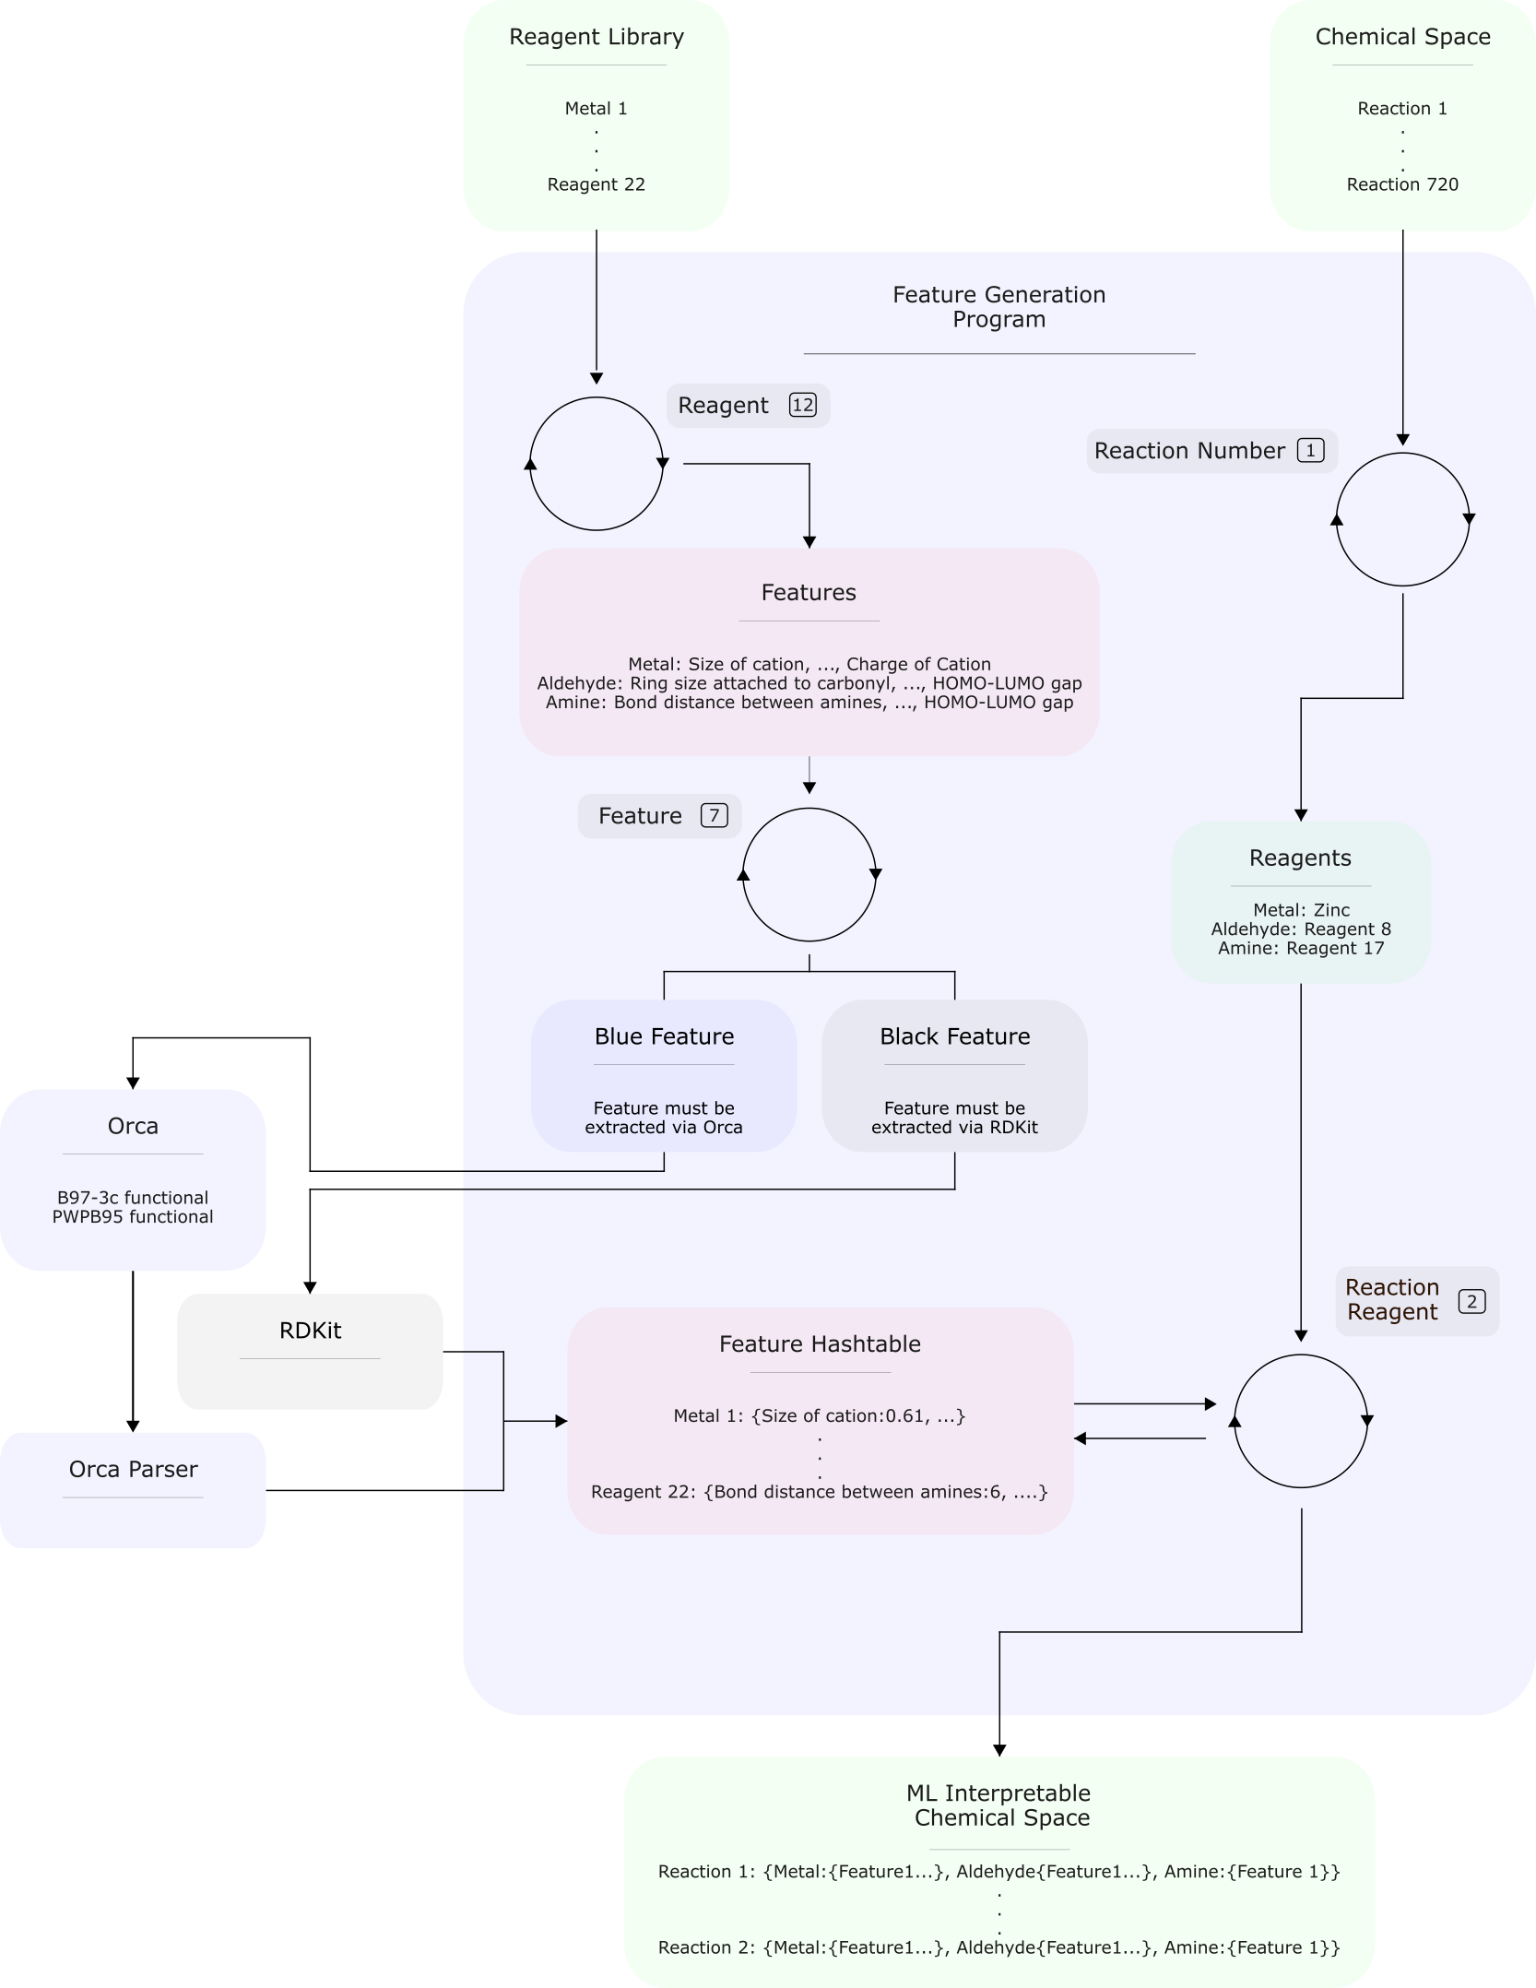

Figure : The programme responsible for the generation of features. A hash table is first populated with reagents, and its features extracted via either orca or RDkit. Reactions in the chemical space are then iterated through, and the reagents in the reactions are then iterated through mapped to the hash table to get an ML interpretable reaction. When the reaction number count hits 720 and the reaction reagent count hits 3, the generated chemical space is populated by all 720 ML interpretable reactions.

This programme takes in reagent libraries and the chemical space generated by the previous programme. Since reactions are represented by their reagents and there are a limited number of starting reagents, a hash table is first populated with reagents and features. Having a hash table reduces computational resources as features are not extracted on a reaction basis. Therefore, the programme first iterates through the reagent library. The features to extract are then iterated through and checked if they must be extracted via RDKit or Orca (see black and blue features in Figure 6). RDKit is cheminformatic toolkit and Orca is an app for quantum mechanical calculations23.

If Orca is required, the reagent first undergoes geometry optimization with B97-3c functionals, then energies are calculated with PWPB95 functionals. Both functionals were used as they are relatively not computationally expensive, and still provide accurate results. These functionals allows the programme to perform computations on a mid-range pc such as the one used in the workflow. Features are then extracted from calculations using a free parsing tool24.

Once features are extracted they are saved into the hash table. Once the hash table is fully populated with all starting reagents, reactions in the chemical space are iterated through and their reagents extracted. The reagents are then taken one at a time and mapped onto the hash table to retrieve their feature values (Figure 5). The final reaction is composed of the starting reagents and their features. The newly defined reaction populates a chemical space interpretable by ML. With the features collected, the ML interpretable space now requires labels.

### Set Up Robotic Workflow

To generate labels, reactions in the chemical space need to be physically tested and analysed. To do so robotically, a few modifications to the synthesis platform needs to be done, reagent solubilities tested and a programme to schedule reactions and communicate between platforms needs to be written. These modifications and tests (Figure 6) were done to hasten workflow setup times and to improve robotic reliability.

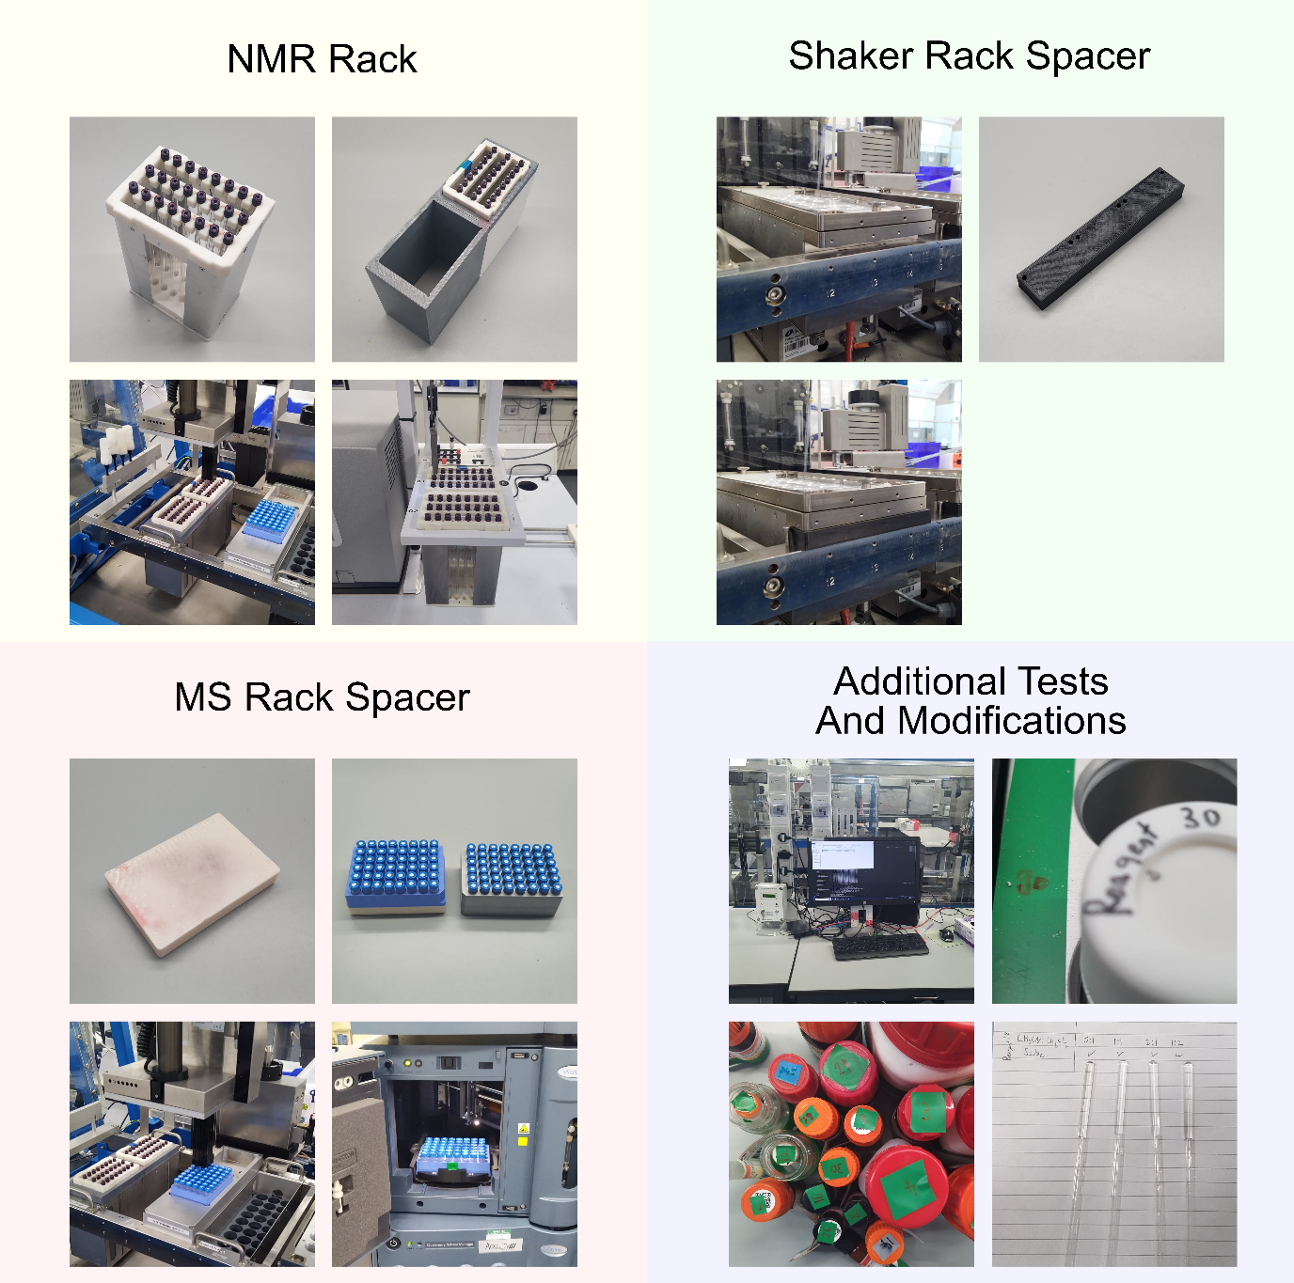

Figure : Modifications done to the platform along with required tests. These include developing a new NMR rack which is compatible in both ChemSpeed and NMR platforms, a spacer to ensure compatibility between ChemSpeed and shaker rack, an MS spacer so that LCMS racks can be used in the ChemSpeed platform, a computer with internet connection connected to the ChemSpeed, labelling of shaker rack areas to their corresponding reagents, and testing reagent solubilities in acetonitrile and / or dichloromethane. Pictures in yellow show: the inhouse developed and built NMR rack (top left); the 3D printed NMR rack adapter (top right); the NMR rack and adapter in the ChemSpeed platform (bottom left); and the NMR rack in the NMR machine (bottom right). Pictures in Green show the gap between the shaker rack and the ChemSpeed rack support (top left); the 3D printed spacer (top right); and the spacer wedged between shaker rack and support (bottom left). Pictures in red show: the LCMS spacer (top left); the LCMS rack stacked on the spacer next to the original ChemSpeed LCMS rack (top right); the spacer and LCMS rack in the ChemSpeed (bottom left); and the LCMS rack in the LCMS machine (bottom right). Pictures in blue show: the external pc connected to the ChemSpeed (top left); the labelled areas in the shaker rack (top right); some of the corresponding labelled reagents (bottom left); and some reagent solubility test (bottom right).

The ChemSpeed platform is controlled by an old computer running windows 7 with no internet connection. To be able to run the scheduling programme, an internet connection for cross platform communication along with an updated version of windows is required. This was fixed by adding an external pc, and creating a local network along with the ChemSpeed pc.

NMR is used to analyse reactions. Therefore, an NMR sample rack which is compatible with both NMR and ChemSpeed platforms was developed and built from in house 3D printed parts, and in house cut aluminium sheets (Figure 6). Furthermore, samples will be dispensed via a hole in the NMR tubes via the ChemSpeed liquid handler syringe. This requires extremely tight tolerances for the workflow to be reliable. Hence, a new NMR rack adapter for the ChemSpeed was designed and 3D printed (Figure 6). This new design holds NMR racks from the top, much like the NMR machine, reducing the degrees of freedom between the ChemSpeed rack support and the NMR tube hole. Tests were done to ensure tight fit tolerances between ChemSpeed rack support, NMR rack adapter and NMR racks. These modifications allowed for the reliable automated dispensing of samples to NMR tubes.

To reduce setup times, an LCMS spacer was designed and 3D printed. The original ChemSpeed LCMS rack is incompatible with the LCMS machine, to mitigate this, a standard LCMS rack is used in conjunction with the designed spacer (Figure 6). Therefore, for a run, LCMS vials do not have to be transferred between racks and the standard rack can be directly taken from the ChemSpeed to the LCMS machine to run MS experiments.

Moreover, to fully dissolve reagents in solvents, two shaker racks were taken from another platform and added to the setup allowing for vial agitation. To make the racks ChemSpeed Swing compatible, spacers that fit between the shaker rack and the rack support were designed and 3D printed (Figure 6). Spacers keep the shaker racks held to the support rack removing the need to recalibrate shaker vial locations after reach run.

Since reagents have different solubilities, solubility tests with acetonitrile and dichloromethane were carried out at different ratios. Acetonitrile and dichloromethane were selected as solvents because the bench top NMR is capable of supressing their NMR peaks, and their peak positions have minimal overlap with reagent peaks. Different ratios were chosen to ensure maximal solubility and prevents any reagents from crashing out during robotic handling. Solubility testing, therefore, played an important role for robotic chemical handling and clean spectra acquisition.

Lastly the workflow was unable to automate solid dispensing as this is still an unsolved problem in chemistry. This requires the chemist to load charged vials into the platform. Often, 10 or more reagents must be loaded for reach run. Having a labelled zone to quickly identify where charged vials belong, cuts down set up times and reduces human error. Hence, the shaker racks were numerated based on reagent IDs (Figure 6).

With the tests and physical modifications in place, a programme that takes the chemical space, schedules reactions in batches and communicates between LCMS, NMR and synthesis platforms is needed. This programme was written in python and is run on the external pc (Figure 6) and its functionality is shown in Figure 7.

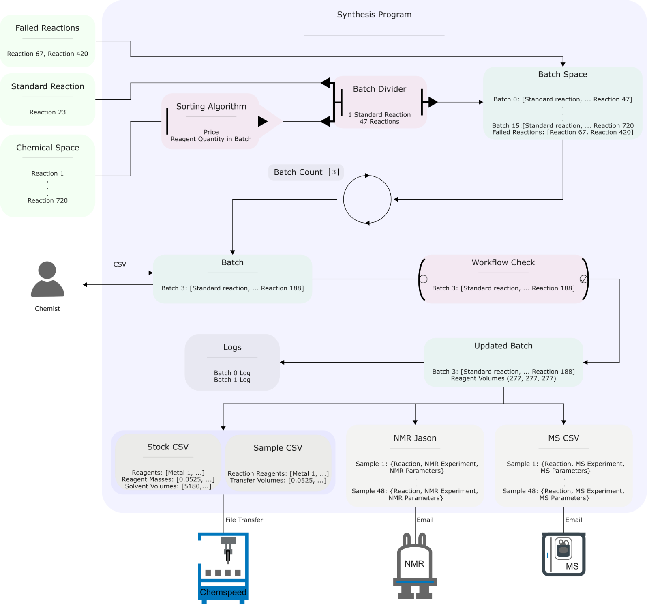

Figure : The logic and organisation of the synthesis program which is responsible for scheduling reactions for synthesis and analysis on ChemSpeed, NMR and MS platforms. The program takes in the chemical space, sorts it, divides it up into batches and adds a standard reaction for each batch to give, the batch space. Batches are then extracted from the batch space depending on batch count. The batch then generates a csv of all the reagent masses required to make up the reactions in the run. This csv is read and filled by a chemist and then, checked by the program to create updated batches. The updated batches are then stored in logs, generate Stock, Sample, MS CSVs and a NMR Json. The CSVs and Jason files are then sent to their respective platforms. It is possible to retake failed reactions, by re-writing them to the batch space.

The program initially takes in the chemical space generated previously, and sorts it based on reaction price and reagents. The workflow is plagued with errors once first set up. Hence the first few batches typically fail. When a batch or reaction fails, these can be easily retaken by the programme. The sorting algorithm is therefore responsible for selecting the cheapest reaction first to minimise expenses. Additionally, the ChemSpeed platform is incapable of handling solids and is limited to handling 48 reactions at once. This requires the workflow to be broken down into 16 batches each of which requires the chemist to weigh out reagents. Therefore, the sorting algorithm also selects batch reactions to minimise the number of reagents the chemist has to weigh. Consequently, sorting the chemical space reduces expenses and chemist physical efforts.

The sorted chemical space is then divided into batches of 47 along with an added standard reaction to generate the batch space. The standard reaction allows the chemist to quickly check if reaction parameters and machinery conditions were kept consistent between runs. The standard reaction is selected based on a successful reaction with a clean spectrum, allowing quick NMR interpretation for both the chemist and workflow. The standard reaction used was reaction 23 which is a combination of iron, reagent 3, and reagent 17. Therefore, standard reactions play the roll of quality control.

Batches are then extracted by the batch space depending on the batch count. For example, a batch count of 3 extracts batch 3 from the batch space. Batch count starts at count 0 and ends at count 15. The count is updated by the program only once the Stock CSV, Batch CSV, MS CSV and NMR Jason have been generated.

As mentioned previously, the synthesis platform is incapable of solid dispensing. Hence, the extracted batch, generates a csv of reagent masses for the chemist to weigh. The chemist then adds the masses of the weighed reagents into the csv to be read by the program. The weighed masses and synthesis platform then undergo a series of checks before generating the updated batch (Figure 7). Checking chemist input catches errors where either no masses have been added or extreme cases. For example, where 20g of reagent were measured instead of 0.2g. The program also forces the chemist to check: if NMR vails, LCMS vials, charged reagent vials, reaction vials have been added; if solvents reservoirs are full; and if the waste reservoir is empty. The locations of the vials and reservoirs are shown in S 2. Therefore, the check ensures a complete setup before generating the updated batch, reducing failed runs.

The updated batch then is stored as logs and is used to generate a Stock CSV, a Sample CSV, a MS CSV, and a NMR Jason. CSVs were generated for the ChemSpeed as it’s the only input it takes. While Jsons and CSVs were generated for the NMR and LCMS machines as it’s the input type the autosampler takes in. Stock and Sample CSV are read by the ChemSpeed platform and provides information on how to make up the stock solutions (based on reagent solubilities tests determined before), and how to transfer stock solutions into reaction vials (to form reaction combinations in the batch). Both Stock and Sample CSV are transferred to the ChemSpeed via a shared folder on the local network. The MS CSV is sent to the LCMS autosampler via email and contains information on the aliquot volume, sample number, and several other MS parameters. For example, if samples need to pass through a column. The NMR Jason is sent to the NMR autosampler via email and contains information on the sample, and several NMR parameters. For example, the number of scans. These output files therefore dictate the behaviour of the platforms to create a batch.

Once the program generates the output files, the chemist is then responsible for running the synthesis platform, visually checking for failed reactions and transferring samples between ChemSpeed, NMR and LCMS platforms. A visual inspection for failed reactions is required, as often, seals in reaction vials are broken, causing the evaporative loss of reaction mixtures. Failed reactions can be re-feed into the programme to then be rerun.

With the robotic set up fully in place, the reactions in the chemical space can be synthesised and their NMR and MS spectra taken. What is now required is the setup of the decision maker, which determines if a reaction is successful or not based on NMR and MS alone.

### Set Up Decision Maker

The heuristic decision maker was previously developed in the group. It aims to mimic the human decision-making process when analysing a spectrum for reactivity. Hence, it contains domain knowledge in its heuristics. The logic of the decision maker is shown Figure 8.

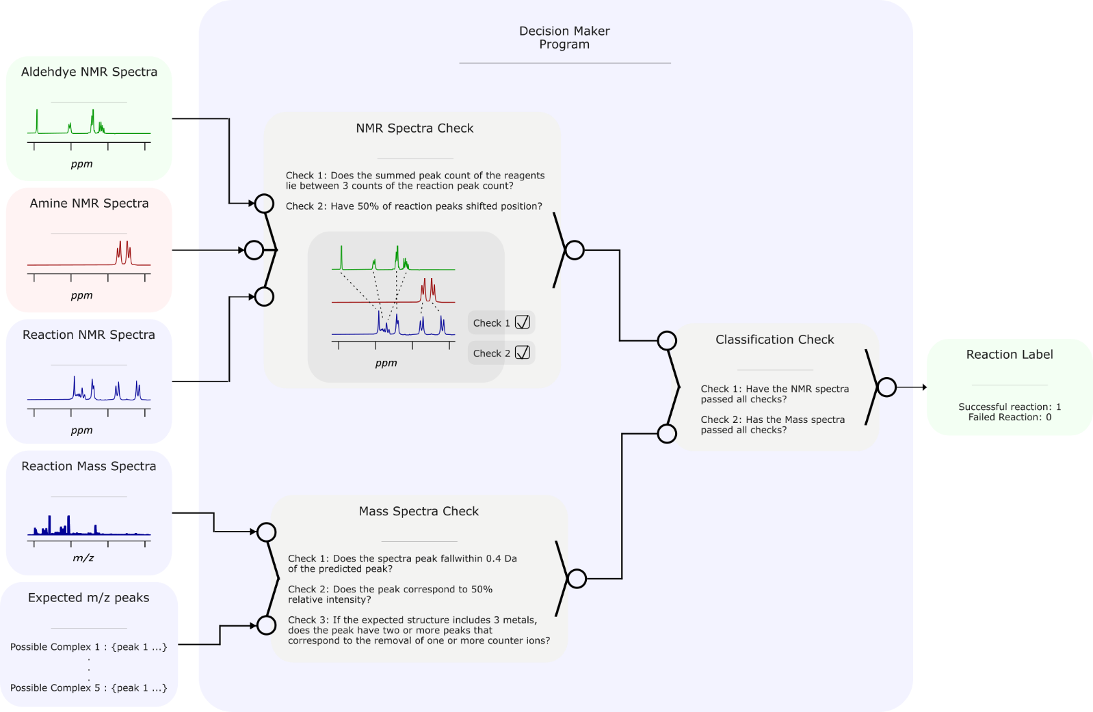

Figure : The decision maker. It takes in the starting material NMR spectra, the reaction NMR spectra, the reaction mass spectra and the expected peaks of the mass spectra. The reagent and reaction NMR spectra are then compared to chemist defined heuristics to determine if a reaction has occurred or not. The reaction mass spectra and predicted mass peaks are also compared by chemist defined heuristic to determine if a supramolecular complex has formed. If both mass and NMR spectra pass all heuristics, the reaction is labelled as successful.

The decision maker takes the starting material NMR spectra, the reaction NMR spectra, the reaction mass spectra, and the expected mass peaks. The expected peaks correspond to molecular ion peaks of possible formed complexes, each with different numbers of counter ions. NMR spectra indicates if a reaction has occurred while the mass spectra indicates if a supramolecular compound has formed. Therefore, both spectra are analysed.

Decision maker compares reagent NMR spectra and reaction spectra based on peak count and chemical shift in two separate checks (Figure 8). If 50% of reagent peaks are shifted, the first check is passed. Since a low field NMR machine was used, these shifts may cause overlap or a change in multiplet shape. Hence, the second check ensures the sum of the number of peaks in reagent NMR fall within 3 counts of the number of peaks of the reaction NMR.

Decision maker compares the reaction mass spectra and expected mass peaks based on three checks. The first check ensures the reaction mass peak falls within 0.4 Da of the expected peak, and the second checks if this peak has a relative intensity of at least 50%. The third check ensures that if the predicted structure has to or more metals, two peaks that satisfy check 1 and check 2 have been found. This reduces the number of false positives caused by the shear amount of possible expected mass peaks.

The percentage of shifted NMR peaks, the range of NMR peak count, the range of mass peak hit, and the relative intensity of mass peak, are all parameters which can be varied. Hence, 94 reactions were labelled by an expert chemist and parameters optimized until decision maker and human labels best converged.

Once all checks for both spectra are passed, then the reaction is labelled as successful. Decision maker now allows the machine interpretable chemical space to be populated with labels.

### Label Acquired Reactions

With the robotic platforms and decision maker all setup, the reactions and their spectra taken, labels for each reaction can be generated. This is handled by the program in Figure 9, the simplest so far.

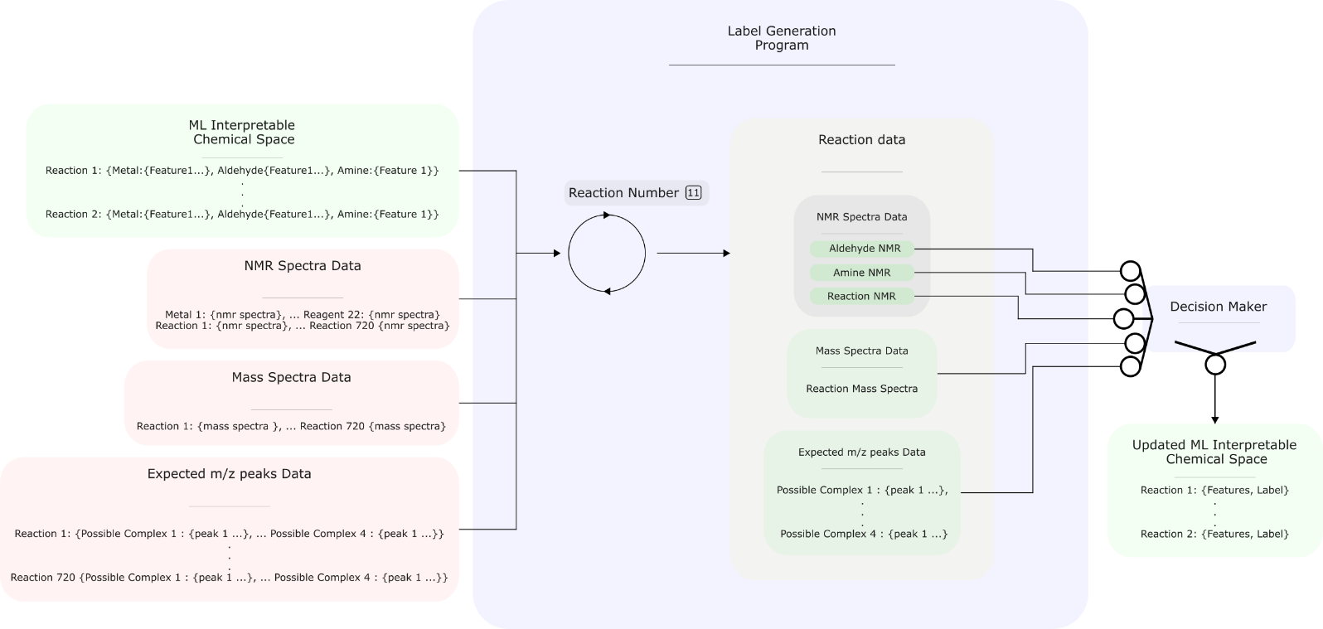

Figure : The logic behind the programme that takes in all spectra data, feeds it to decision maker to generate a chemical space filled by reactions with both features and labels. This program is a simple loop.

While simple, the programme plays a fundamental role in tying together features, spectra, and labels. The program is a loop that iterates through each reaction, and with it its features, and feeds decision maker with its NMR and mass spectra along with its reagent NMR spectra and expected mass peaks (Figure 9). This then generates a label for the reaction. The final output of the program is a chemical space with reactions, features and labels. This is the dataset to be analysed and used with machine learning models.

## Data Generation

The next few steps include carrying out reactions, taking NMR and MS spectra to then decide if a combination results in a supramolecular compound. The process of carrying out and analysis of chemical space is handled by a Chemspeed Swing platform, a Bruker benchtop NMR machine, and a Waters Acquity LCMS system (Figure 8).

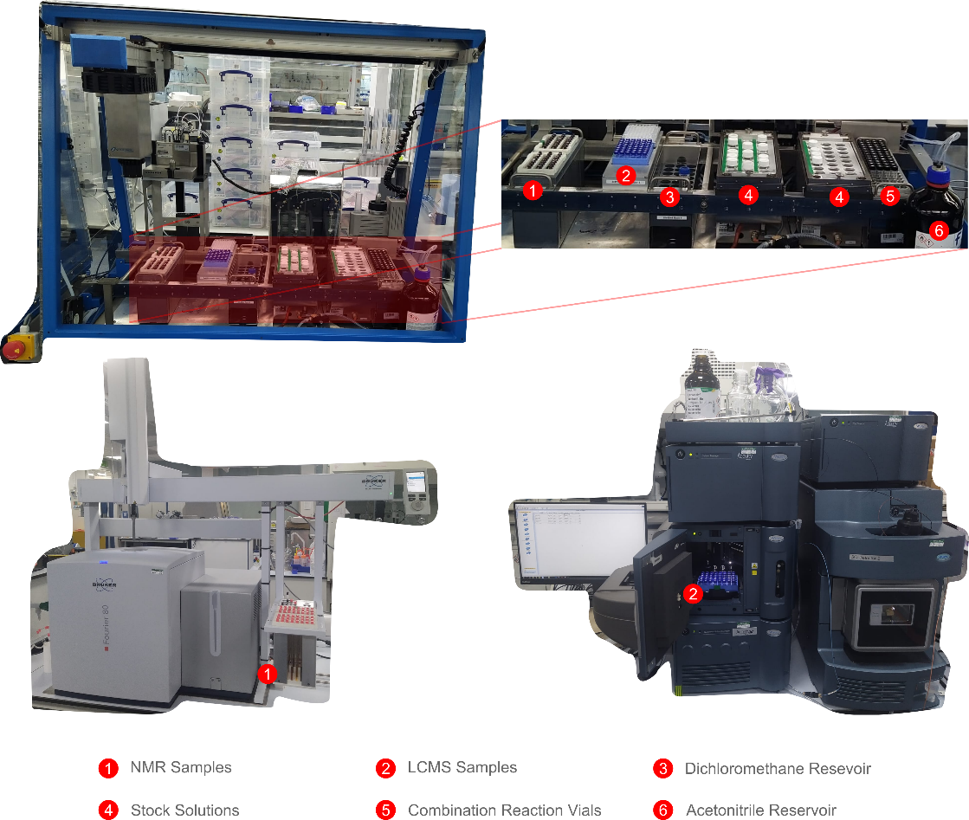

Figure : The three platforms used in the workflow. At the top is the Chemspeed platform, responsible for making up stock solutions, reactions scheduled by a programme and taking NMR and LCMS samples for each combination. At the bottom left is the benchtop NMR used in the workflow along with the in-house built NMR sample rack. At the bottom right is the LCMS machine used in the workflow, along with reaction samples.

Since platforms are independent of each other and are limited to 48 samples, a programme must schedule and communicate samples to make up between platforms. The same programme is also responsible for labelling combinations as failed or successful reactivities. All programmes and algorithms used in these stages were developed by the research group. Lastly, since everything is defined via an abstracted programme, expansion of the workflow, and use for other areas of chemistry is simple. The workflow the programme follows and its capabilities are shown in Figure 9.

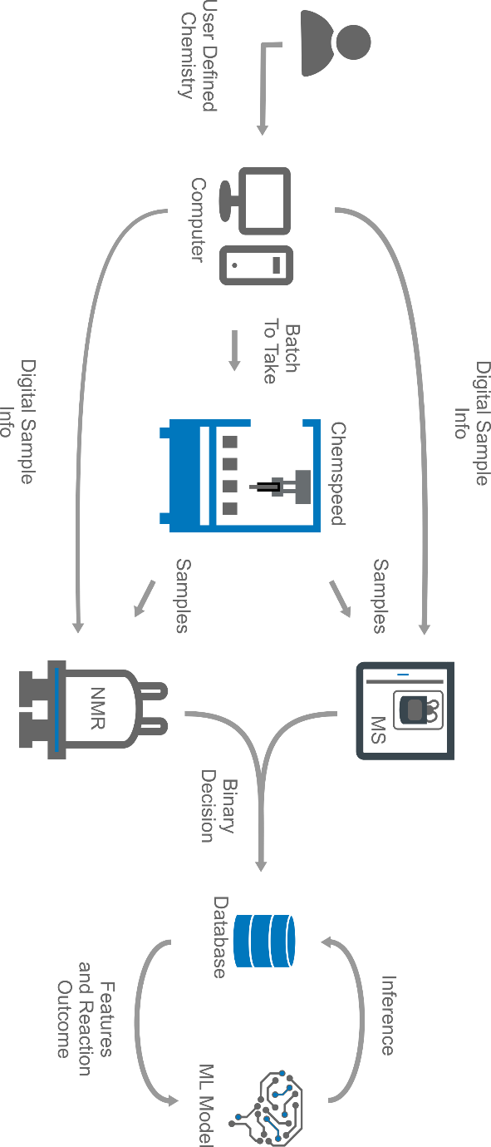

Figure : The overall workflow the programme manages shown as a sequence of steps. The logical order shown in the diagram is the same as the one taken out physically. There are four main pieces of equipment: a centralised computer to store data and manage tasks, a ChemSpeed platform to carry out reactions, an NMR and LCMS machine to analyse data.

Once the chemist digitally defines reaction, subdivisions, and reagents into the programme (**Error! Reference source not found.**), the combination space to explore is generated by the programme. The space is then filtered by price and reagents. Early stages of workflows are prone to errors, hence starting with the cheapest reagents reduces project expenses. Reagent masses are measured manually, hence minimising the number of reagents to measure in a batch reduces manual labour.

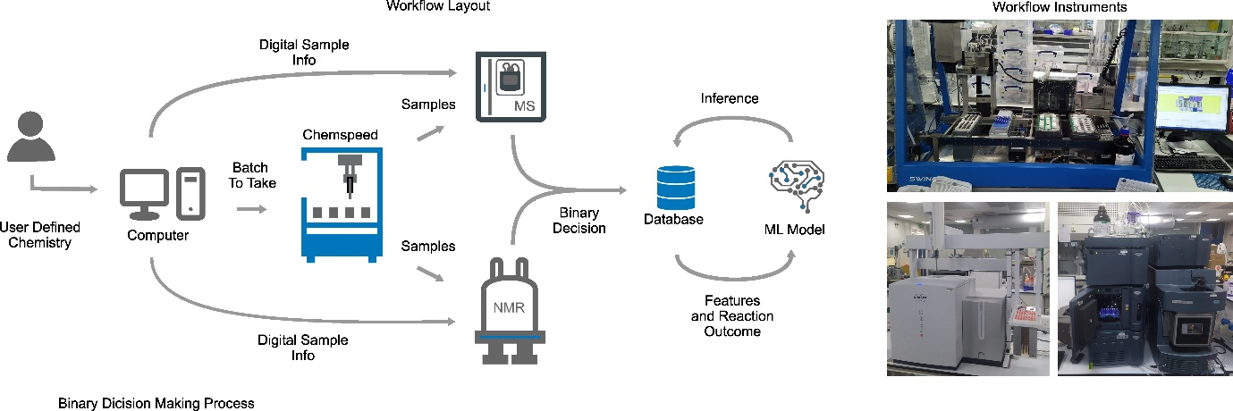

After sorting the chemical space, standard reactions are added to quickly assess the quality of a batch. Only then are batches sent as digital samples to the robotic, NMR and LCMS platforms. Next, the robotic platform makes up the reactions and creates samples for the chemist to then transport to the NMR and LCMS machines, which thanks to the digital sample knows what sample corresponds to what combination. With analytical data acquired, the programme uses chemical shifts and peak positions from 1HNMR data to determine if a reaction has occurred, it then uses m/z ratios from mass spec (MS) data to determine the size of the supramolecular structure (it is possible that only imines are formed and not a complex, MS data helps identify such combinations). The final output of the algorithm is a binary classification (0,1) of what combinations yield discrete, diamagnetic, supramolecular structures.

Unfortunately, the analytical classification algorithm introduces bias to the dataset. It is only able to classify discrete, diamagnetic species. High spin iron (II) complexes, and oligomers will not be accounted for, although preliminary manually curated results demonstrated such products do exist in the paper’s chemical space. Fortunately, this is an algorithmic limitation, which could be solved by building better tools. The fundamental dataset remains unaffected. Future development would improve ML model predictions and will offer more robust insights into the dataset.

Once all reactions have been carried out and classified, it is stored in a local database to then be used for ML model training and SHAP analysis. This is the data exploration step in Figure 1.

## Data Exploration

Data still needs to be collected ☹. Talk about feature selection.

## X-ray Crystallographic data

After reaction combinations were sampled for NMR and MS, remaining solutions in the reaction vials were left to evaporate for 2 weeks. This makeshift method of crystal growth rarely worked, giving us only X-amount of samples. Supramolecular structures can be seen in FIGURE X.

# Spared information to be compiled into a coherent document.

## References

(1) Schrader, M. L.; Schäfer, F. R.; Schäfers, F.; Glorius, F. Bridging the Information Gap in Organic Chemical Reactions. *Nat. Chem.* **2024**, *16* (4), 491–498. https://doi.org/10.1038/s41557-024-01470-8.

(2) Nippa, D. F.; Atz, K.; Müller, A. T.; Wolfard, J.; Isert, C.; Binder, M.; Scheidegger, O.; Konrad, D. B.; Grether, U.; Martin, R. E.; Schneider, G. Identifying Opportunities for Late-Stage C-H Alkylation with High-Throughput Experimentation and in Silico Reaction Screening. *Commun. Chem.* **2023**, *6* (1), 1–11. https://doi.org/10.1038/s42004-023-01047-5.

(3) Zhang, D.; Ronson, T. K.; Nitschke, J. R. Functional Capsules via Subcomponent Self-Assembly. *Acc. Chem. Res.* **2018**, *51* (10), 2423–2436. https://doi.org/10.1021/acs.accounts.8b00303.

(4) Chakrabarty, R.; Mukherjee, P. S.; Stang, P. J. Supramolecular Coordination: Self-Assembly of Finite Two- and Three-Dimensional Ensembles. *Chem. Rev.* **2011**, *111* (11), 6810–6918. https://doi.org/10.1021/cr200077m.

(5) Noh, J.; Doan, H. A.; Job, H.; Robertson, L. A.; Zhang, L.; Assary, R. S.; Mueller, K.; Murugesan, V.; Liang, Y. An Integrated High-Throughput Robotic Platform and Active Learning Approach for Accelerated Discovery of Optimal Electrolyte Formulations. *Nat. Commun.* **2024**, *15* (1), 2757. https://doi.org/10.1038/s41467-024-47070-5.

(6) Cook, T. R.; Zheng, Y.-R.; Stang, P. J. Metal–Organic Frameworks and Self-Assembled Supramolecular Coordination Complexes: Comparing and Contrasting the Design, Synthesis, and Functionality of Metal–Organic Materials. *Chem. Rev.* **2013**, *113* (1), 734–777. https://doi.org/10.1021/cr3002824.

(7) Caramelli, D.; Granda, J. M.; Mehr, S. H. M.; Cambié, D.; Henson, A. B.; Cronin, L. Discovering New Chemistry with an Autonomous Robotic Platform Driven by a Reactivity-Seeking Neural Network. *ACS Cent. Sci.* **2021**, *7* (11), 1821–1830. https://doi.org/10.1021/acscentsci.1c00435.

(8) Abolhasani, M.; Kumacheva, E. The Rise of Self-Driving Labs in Chemical and Materials Sciences. *Nat. Synth.* **2023**, *2* (6), 483–492. https://doi.org/10.1038/s44160-022-00231-0.

(9) Li, X.; Maffettone, P. M.; Che, Y.; Liu, T.; Chen, L.; Cooper, A. I. Combining Machine Learning and High-Throughput Experimentation to Discover Photocatalytically Active Organic Molecules. *Chem. Sci.* **2021**, *12* (32), 10742–10754. https://doi.org/10.1039/D1SC02150H.

(10) Renom-Carrasco, M.; Lefort, L. Ligand Libraries for High Throughput Screening of Homogeneous Catalysts. *Chem. Soc. Rev.* **2018**, *47* (13), 5038–5060. https://doi.org/10.1039/C7CS00844A.

(11) Rulev, A. Y. Serendipity or the Art of Making Discoveries. *New J. Chem.* **2017**, *41* (11), 4262–4268. https://doi.org/10.1039/C7NJ00182G.

(12) O’Shaughnessy, M.; Glover, J.; Hafizi, R.; Barhi, M.; Clowes, R.; Chong, S. Y.; Argent, S. P.; Day, G. M.; Cooper, A. I. Porous Isoreticular Non-Metal Organic Frameworks. *Nature* **2024**, *630* (8015), 102–108. https://doi.org/10.1038/s41586-024-07353-9.

(13) Rodríguez-Pérez, R.; Bajorath, J. Interpretation of Compound Activity Predictions from Complex Machine Learning Models Using Local Approximations and Shapley Values. *J. Med. Chem.* **2020**, *63* (16), 8761–8777. https://doi.org/10.1021/acs.jmedchem.9b01101.

(14) Goral, V.; Nelen, M. I.; Eliseev, A. V.; Lehn, J.-M. Double-Level “Orthogonal” Dynamic Combinatorial Libraries on Transition Metal Template. *Proc. Natl. Acad. Sci.* **2001**, *98* (4), 1347–1352. https://doi.org/10.1073/pnas.98.4.1347.

(15) Safont-Sempere, M. M.; Fernández, G.; Würthner, F. Self-Sorting Phenomena in Complex Supramolecular Systems. *Chem. Rev.* **2011**, *111* (9), 5784–5814. https://doi.org/10.1021/cr100357h.

(16) *Supramolecular chemistry and self-assembly*. https://doi.org/10.1073/pnas.062524299.

(17) Collins, N.; Stout, D.; Lim, J.-P.; Malerich, J. P.; White, J. D.; Madrid, P. B.; Latendresse, M.; Krieger, D.; Szeto, J.; Vu, V.-A.; Rucker, K.; Deleo, M.; Gorfu, Y.; Krummenacker, M.; Hokama, L. A.; Karp, P.; Mallya, S. Fully Automated Chemical Synthesis: Toward the Universal Synthesizer. *Org. Process Res. Dev.* **2020**, *24* (10), 2064–2077. https://doi.org/10.1021/acs.oprd.0c00143.

(18) Manzano, J. S.; Hou, W.; Zalesskiy, S. S.; Frei, P.; Wang, H.; Kitson, P. J.; Cronin, L. An Autonomous Portable Platform for Universal Chemical Synthesis. *Nat. Chem.* **2022**, *14* (11), 1311–1318. https://doi.org/10.1038/s41557-022-01016-w.

(19) van Dam, A.; van Schendel, R.; Gangarapu, S.; Zuilhof, H.; Smulders, M. M. J. DFT Study of Imine-Exchange Reactions in Iron(II)-Coordinated Pincers. *Chem. – Eur. J.* **2023**, *29* (61), e202301795. https://doi.org/10.1002/chem.202301795.

(20) Ayme, J.-F.; Beves, J. E.; Campbell, C. J.; Leigh, D. A. Probing the Dynamics of the Imine-Based Pentafoil Knot and Pentameric Circular Helicate Assembly. *J. Am. Chem. Soc.* **2019**, *141* (8), 3605–3612. https://doi.org/10.1021/jacs.8b12800.

(21) Ayme, J.-F.; Lehn, J.-M.; Bailly, C.; Karmazin, L. Simultaneous Generation of a [2 × 2] Grid-Like Complex and a Linear Double Helicate: A Three-Level Self-Sorting Process. *J. Am. Chem. Soc.* **2020**, *142* (12), 5819–5824. https://doi.org/10.1021/jacs.0c00896.

(22) Bennett, K. J.; Bates, A. L.; Carolan, A. N.; Jones, S. B.; Lee, H.-S.; Hancock, R. D. Complexation of Lanthanide(III) and Yttrium(III) Cations with Terpyridyl, Dipyridoacridine, and 1,10-Phenanthroline in Aqueous Solution. Importance of Covalence in Metal–Ligand Bonding in Complexes of Lanthanides with Nitrogen Donor Ligands. *Inorganica Chim. Acta* **2023**, *557*, 121669. https://doi.org/10.1016/j.ica.2023.121669.

(23) Neese, F. (2012) The ORCA Program System, Wiley Interdiscip.

(24) Alexander T. (2024) Orca-Parser 0.2.4.

# Supplementary Information

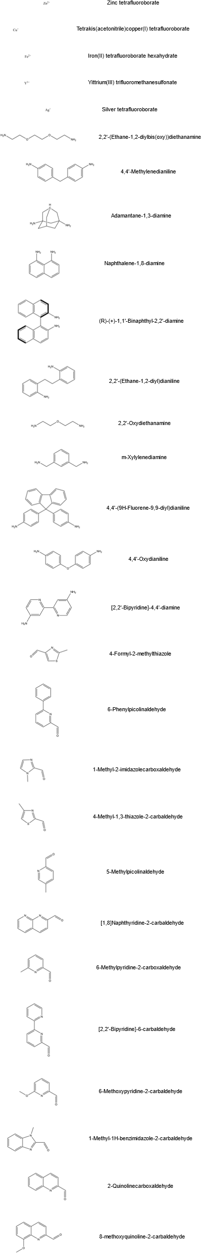

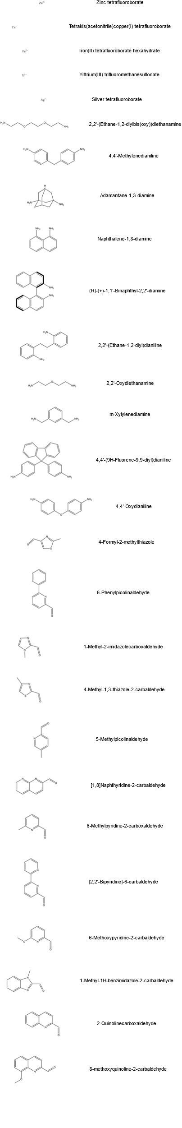

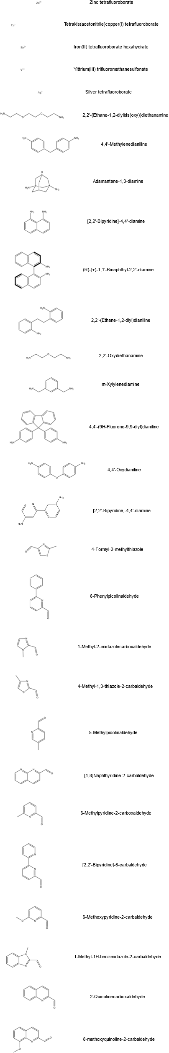

S : A table of reagent names and structures used in the study.

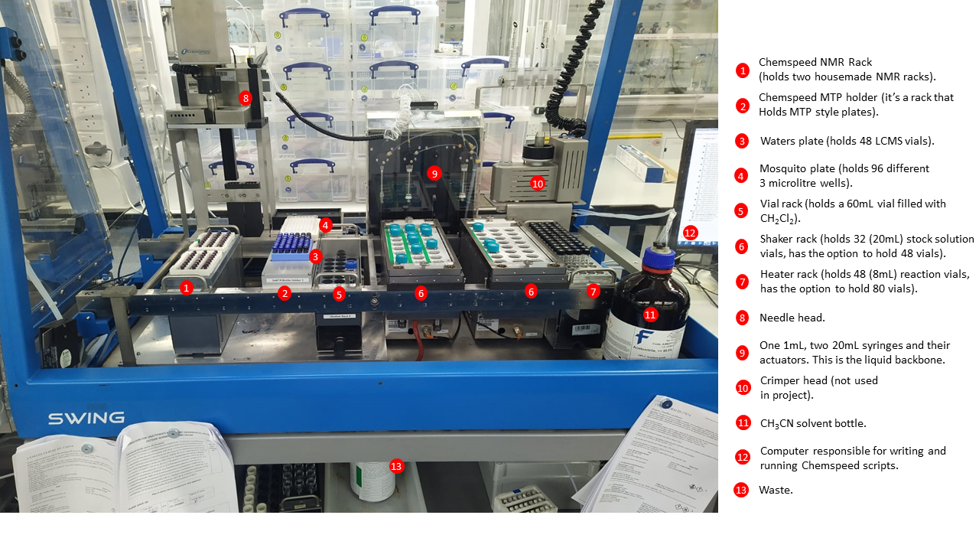

S : The physical setup of the synthesis (ChemSpeed Swing) platform. The relevant areas are marked via an index. The above shows the platform ready for a run.